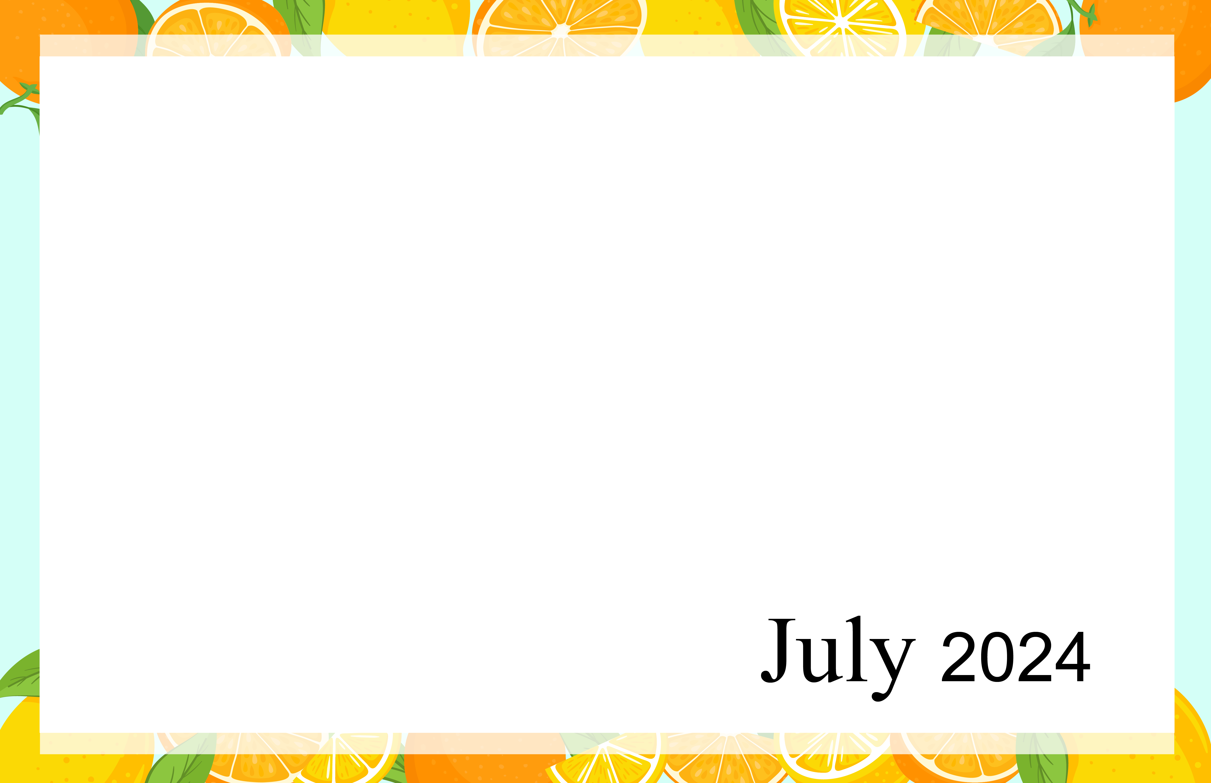Additional Activities:  Croquet – 7/5 at 3pm  Walking Group – at 1:15pm  Birthday’s:  Mrs. Davis – 7/2  Mr. Daley 7/4  Mrs. Grayson – 7/12  Mrs. Brooks – 7/29 |  | 10:00 Juicy News  11:00 Music with Logan &  Madelaine  (Fei Gathering)  1:00 Relaxation Period  2:00 History on Canada Day  3:00 Snack Social  4:00 Bible Time |  | 10:00 Communion (W)  10:30 Communion (E)  11:00 Art Class  1:00 Relaxation Period  1:45 Scenic Bus Ride (W)  2:00 Exercise w/ Laura (E)  3:00 Snack & Chat  4:00 Trip to Boston | 10:00 Spa Day  1:00 Relaxation Period  2:00 Exercise w/ Sherry (W)  2:30 Exercise w/ Sherry (E)  3:00 Happy Hour  4:00 Making Straw Star Door  Decor | 10:00 Current Events  11:00 Art Class  1:00 Relaxation Period  2:00 Exercise w/ Sherry (W)  2:30 Exercise w/ Sherry (E)  3:30 Fourth of July Party &  Fireworks Jokes  Happy 4th of July | 10:00 Jeopardy Trivia  1:00 Relaxation Period  1:45 Scenic Bus Ride (E)  2:00 Noodle Ball (W)  3:00 Snack & Chat  4:00 Movie Moment (Netflix) | 10:00 Exercise w/ Wellness  Team  11:00 Piano Music w/ Gary  Pecorella (Halkyard  Atrium)  1:00 Relaxation Period  2:00 Ice Cream Social  3:00 Puzzle Gathering
10:30 Church Service Virtual  (YouTube)  1:00 Relaxation Period  2:00 Reminiscing (Patio)  3:00 Snack & Chat  4:00 Evening Cinema | 10:00 Be Fit: Total body  11:00 Words ending in GHT  1:00 Relaxation Period  2:00 History in the month of  July  3:00 Snack Social  4:00 Bible Time |  | 10:00 Communion (W)  10:30 Communion (E)  11:00 Art Class  1:00 Relaxation Period  1:45 Scenic Bus Ride (W)  2:00 Exercise w/ Laura (E)  3:00 Music w/ Jim Seem  (Encircle)  4:00 Snack & Chat |  | 10:00 BINGO  11:15 Music Therapy  (Encircle)  1:00 Relaxation Period  2:00 Exercise w/ Sherry (W)  2:30 Exercise w/ Sherry (E)  3:00 Happy Hour  4:00 Sing Along | 10:00 Baker’s Batch  11:00 Art Class  1:00 Relaxation Period  2:00 Exercise w/ Sherry (W)  2:30 Exercise w/ Sherry (E)  3:00 Hydration Station  4:00 Piano Music w/ Bob  (Fei Gathering) | 10:00 Making Beach Plaque  11:30 Piano Music w/ Father  Dow (E)  1:00 Relaxation Period  1:45 Scenic Bus Ride (E)  2:00 Table Ping Pong  3:00 Snack & Chat  4:00 Short Stories | 10:00 Exercise w/ Wellness  Team  11:00 Creative drawing  1:00 Relaxation Period  2:00 Snack Social  3:00 Puzzle Gathering
10:30 Church Service Virtual  (YouTube)  1:00 Relaxation Period  2:00 Reminiscing (Patio)  3:00 Snack & Chat  4:00 Evening Cinema | 10:00 Juicy News  11:00 Solving Math Problems  1:00 Relaxation Period  2:00 Finish that Phrase  3:00 Snack Social  4:00 Bible Time |  | 10:00 Communion (W)  10:30 Communion (E)  11:00 Art Class  1:00 Relaxation Period  1:45 Scenic Bus Ride (W)  2:00 Exercise w/ Laura (E)  3:00 Music w/ Sally Perkins  (Scofield Activities)  4:00 Snack & Chat |  | 10:00 Spa Day  1:00 Relaxation Period  2:00 Exercise w/ Sherry (W)  2:30 Exercise w/ Sherry (E)  3:00 Happy Hour  4:00 John Denver Show  (YouTube) | 10:00 Current Events  11:00 Art Class  1:00 Relaxation Period  2:00 Exercise w/ Sherry (W)  2:30 Exercise w/ Sherry (E)  3:00 Hydration Station  4:00 Piano Music w/ Emge  (Fei Gathering) | 10:00 Monopoly  1:00 Relaxation Period  1:45 Scenic Bus Ride (E)  2:00 Noodle Ball  3:00 Snack & Chat  4:00 Wine & Poetry Reading | 10:00 Exercise w/ Wellness  Team  11:00 Guitar music w/  Chuck Gee  (Fei Gathering)  1:00 Relaxation Period  2:00 Ice Cream Social  3:00 Puzzle Gathering
10:30 Church Service Virtual  (YouTube)  1:00 Relaxation Period  2:00 Reminiscing (Patio)  3:00Snack & Chat  4:00 Evening Cinema | 10:00 Be Fit: Stretches  11:00 Noodle Ball w/ Este’s  (Scofield Activities)  1:00 Relaxation Period  2:00 Run the Alphabet  3:00 Snack Social  4:00 Bible Time |  | 10:00 Communion (W)  10:30 Communion (E)  11:00 Art Class  1:00 Relaxation Period  1:45 Scenic Bus Ride (W)  2:00 Exercise w/ Laura (E)  3:00 Snack & Chat  4:00 Trip to Washington DC |  | 10:00 Words begin with RE  11:15 Music Therapy  (Fei Gathering)  1:00 Relaxation Period  2:00 Exercise w/ Sherry (W)  2:30 Exercise w/ Sherry (E)  3:00 Happy Hour  4:00 Sing Along | 10:00 Baker’s Batch  11:00 Art Class  1:00 Relaxation Period  2:00 Exercise w/ Sherry (W)  2:30 Exercise w/ Sherry (E)  3:00 Hydration Station  4:00 Piano Music w/ Bob  (Encircle) | 10:00 Stakes are High  11:30 Piano Music w/ Father  Dow (W)  1:00 Relaxation Period  1:45 Scenic Bus Ride (E)  2:00 Word N Word  3:00 Snack & Chat  4:00 Short Stories | 10:00 Exercise w/ Wellness  Team  11:00 Name 5  1:00 Relaxation Period  2:00 Snack Social  3:00 Puzzle Gathering
10:30 Church Service Virtual  (YouTube)  1:00 Relaxation Period  2:00 Reminiscing (Patio)  3:00 Snack & Chat  4:00 Evening Cinema | 10:00 Juicy News  11:00 Olympic Trivia  1:00 Relaxation Period  2:00 Trip to the Olympic  3:30 Monthly Birthday Party  (Fei Gathering) |  | 10:00 Communion (W)  10:30 Communion (E)  11:00 Art Class  1:00 Relaxation Period  1:45 Scenic Bus Ride (W)  2:00 Exercise w/ Laura (E)  3:00 Snack & Chat  4:00 Trip to National Parks |  | 10:00 Spa Day  1:00 Relaxation Period  2:00 Exercise w/ Sherry (W)  2:30 Exercise w/ Sherry (E)  3:00 Happy Hour  4:00 Classical Musician  Bands (YouTube) | ARCADIA
Questions Contact: Martha (Activities Coordinator) at 843-406-6277 or Darlynne (Activities Assistant) at 843-406-2430
Sunday | Monday | Tuesday | Wednesday | Thursday | Friday | Saturday
 | 1  Canada Day | 2 | 3 | 4  Independence Day (US) | 5 | 6
7 | 8 | 9 | 10 | 11 | 12 | 13
14 | 15 | 16 | 17 | 18 | 19 | 20
21 | 22 | 23 | 24 | 25 | 26 | 27
28 | 29 | 30 | 31

